2022 FR Set 1
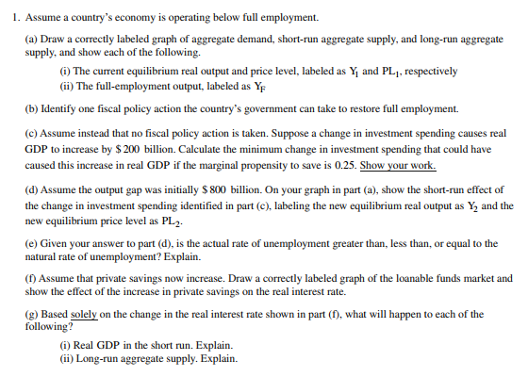

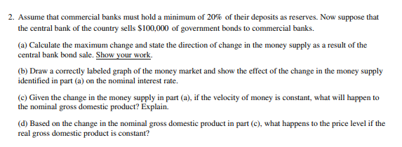

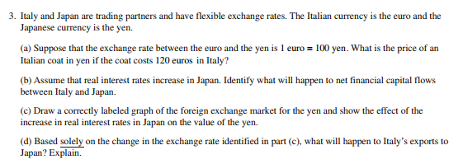
- Assume a country’s economy is operating below full employment.
(a) Draw a correctly labeled graph of aggregate demand, short-run aggregate supply, and long-run aggregate supply, and show:
(i) The current equilibrium real output and price level, labeled as Y and PL1, respectively.
(ii) The full-employment output, labeled as YF.
(b) Identify one fiscal policy action the country’s government can take to restore full employment.
(c) Assume no fiscal policy action is taken. Suppose a change in investment spending causes real GDP to increase by $200 billion. Calculate the minimum change in investment spending that could have caused this increase in real GDP if the marginal propensity to save is 0.25. Show your work.
(d) Assume the output gap was initially $800 billion. On your graph in part (a), show the short-run effect of the change in investment spending identified in part (c), labeling the new equilibrium real output as Y2 and the new equilibrium price level as PL2.
(e) Given your answer to part (d), is the actual rate of unemployment greater than, less than, or equal to the natural rate of unemployment? Explain.
(f) Assume that private savings now increase. Draw a correctly labeled graph of the loanable funds market and show the effect of the increase in private savings on the real interest rate.
(g) Based solely on the change in the real interest rate shown in part (f), what will happen to each of the following?
(i) Real GDP in the short run. Explain.
(ii) Long-run aggregate supply. Explain.

- Assume that commercial banks must hold a minimum of 20% of their deposits as reserves. Now suppose that the central bank of the country sells $100,000 of government bonds to commercial banks.
(a) Calculate the maximum change and state the direction of change in the money supply as a result of the central bank bond sale. Show your work.
(b) Draw a correctly labeled graph of the money market and show the effect of the change in the money supply identified in part (a) on the nominal interest rate.
(c) Given the change in the money supply in part (a), if the velocity of money is constant, what will happen to the nominal gross domestic product? Explain.
(d) Based on the change in the nominal gross domestic product in part (c), what happens to the price level if the real gross domestic product is constant?

- Italy and Japan are trading partners and have flexible rates. The Italian currency is the euro and the Japanese currency is the yen.
(a) Suppose that the exchange rate between the euro and the yen is 1 euro = 100 yen. What is the price of an Italian coat in yen if the coat costs 120 euros in Italy?
(b) Assume that real interest rates increase in Japan. Identify what will happen to net financial capital flows between Italy and Japan.
(c) Draw a correctly labeled graph of the foreign exchange market for the yen and show the effect of the increase in real interest rates in Japan on the value of the yen.
(d) Based solely on the change in the exchange rate identified in part (c), what will happen to Italy’s exports to Japan? Explain.

2022 FR Set 2
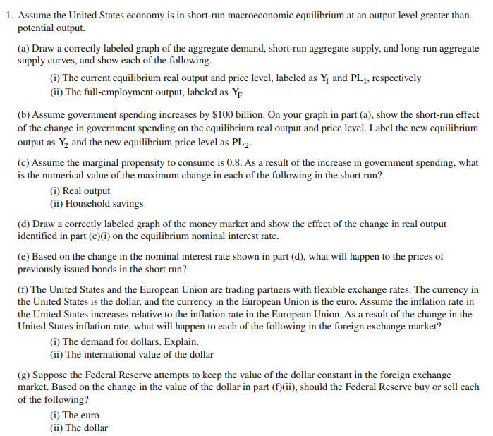

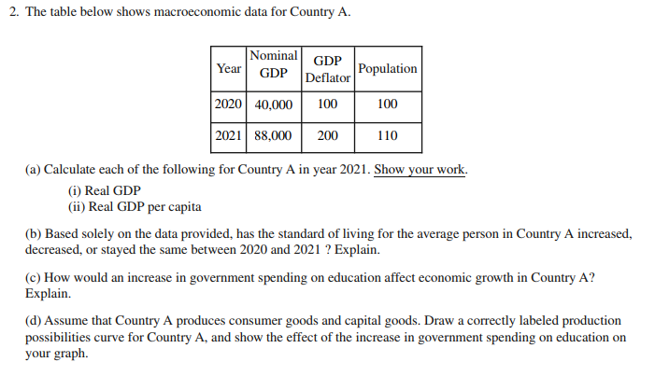

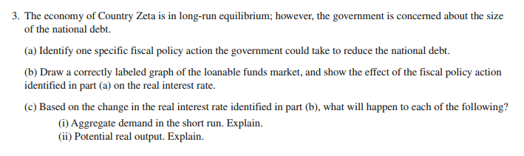

2022 FR Set 2
- Assume the Unite States economy is in short run macroeconomic equilibrium at an output level greater than potential output.
(a) Draw a correctly labeled graph of the aggregate demand, short-run aggregate supply, and long-run aggregate supply curves, and show:
(i) The current equilibrium real output and price level, labeled as Y1 and PL1, respectively.
(ii) The full-employment output, labeled as YF.
(b) Assume government spending increases by $100 billion. On your graph in part (a), show the short-run effect of the change in government spending on the equilibrium real output and price level. Label the new equilibrium output as Y2 and the new equilibrium price level as PL2.
(c) Assume the marginal propensity to consume is 0.8. As a result of the increase in government spending, what is the numerical value of the maximum change in each of the following in the short run?
(i) Real output.
(ii) Household savings.
(d) Draw a correctly labeled graph of the money market and show the effect of the change in real output identified in part (c)(i) on the equilibrium nominal interest rate.
(e) Based on the change in the nominal interest rate shown in part (d), what will happen to the prices of previously issued bonds in the short run?
(f) The United States and the European Union are trading partners with flexible exchange rates. The currency in the United States is the dollar, and the currency in the European Union is the euro. Assume the inflation rate in the United States increases relative to the inflation rate in the European Union. As a result of the change in the United States inflation rate, what will happen to each of the following in the foreign exchange market?
(i) The demand for dollars. Explain.
(ii) The international value of the dollar.
(g) Suppose the Federal Reserve attempts to keep the value of the dollar constant in the foreign exchange market. Based on the change in the value of the dollar in part (f)(ii), should the Federal Reserve buy or sell each of the following?
(i) The euro.
(ii) The dollar.

- The table below shows macroeconomic data for Country A.
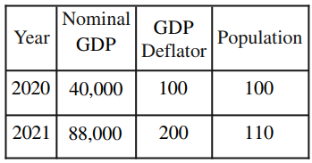
(a) Calculate each of the following for Country A in year 2021. Show your work:
(i) Real GDP.
(ii) Real GDP per capita.
(b) Based solely on the data provided, has the standard of living for the average person in Country A increased, decreased, or stayed the same between 2020 and 2021? Explain.
(c) How would an increase in government spending on education affect economic growth in Country A? Explain.
(d) Assume that Country A produces consumer goods and capital goods. Draw a correctly labeled production possibilities curve for Country A, and show the effect of the increase in government spending on education on your graph.

- The economy of CountryZeta is in long run equilibrium; however, the government is concerned about the size of the national debt.
(a) Identify one specific fiscal policy action the government could take to reduce the national debt.
(b) Draw a correctly labeled graph of the loanable funds market, and show the effect of the fiscal policy action identified in part (a) on the real interest rate.
(c) Based on the change in the real interest rate identified in part (b), what will happen to each of the following?
(i) Aggregate demand in the short run. Explain.
(ii) Potential real output. Explain.

